YaBot

Submitted by:

Submitted to: OACETT

10 Four Seasons Place, Suite 404

Toronto, ON M9B 6H7

Discipline: Computer Engineering Technology

Date Submitted: TBD

# Abstract

# Table of Contents

YaBot

Abstract 2

Table of Contents 3

List of Illustrations 4

1.0 Introduction 5

2.0 Planning (Method) 6

2.1 Requirements 6

2.2 Design Plan 6

2.3 Implementation 7

3.0 Build 9

Figure 3.1 – Wiring Diagram - Two Wheel Drive Robot 11

Figure 3.2 – Wiring Diagram – Swivel Camera 11

4.0 Process 12

5.0 Conclusions 13

6.0 Recommendations 14

7.0 Bibliography 15

8.0 Appendices 16

# List of Illustrations

# 1.0 Introduction

This report entails the planning, design, process, and conclusion of combining two hardware devices to work interdependently with an android software application. This project will be conducted by two group members merging individual hardware projects to create a super bot. A swivel enabled camera which is to be mounted on top of a two-wheel drive robot allowing for mobility, surveillance, and remote control when paired with a Raspberry Pi. The design and creation of the individual hardware will also be covered. The two devices coupled will create what we will call the YaBot. The robot will be mobile and controlled by an android software application either from a smartphone or a tablet. The YaBot will eliminate the need to be physically present to maneuver and observe environments. Ultimately, the YaBot will be able to drive independently when trained on a course. Steering angles, speed, and images will be recorded and used to optimize drive times.

# 2.0 Planning (Method)

## 2.1 Requirements

As a group, we have been given 14 weeks to plan, design, implement and create a report for our YaBot project. We have identified tasks necessary for completion of the venture. These tasks include combining the two-wheel drive robot with a swivel camera into one YaBot. The final outcome of the hardware device is meant to be remotely operated. To accomplish this, an android software application will need to be developed to control both hardware devices simultaneously. It also essential to create and implement a database to store driving statistics for self-driving. Finally, there needs to be an observer and reporter.

For efficiency, the tasks required for successful completion of the project are split between two group members. Both members will be involved in the planning and design of the software application and final hardware device. Both members will also be responsible for supplying individual hardware components. Member A will be accountable for the Swivel Camera component, software design, database design, and report writing. Member B will be responsible for the Two-Wheel robot component, hardware design, android software development, and report editing. As a group, ideas and suggestions will be shared regularly for potential improvements of the final design.

## 2.2 Design Plan

The YaBot is to have a Raspberry Pi 3 (RPi) used as a central control system for the hardware components. The RPi will be programmed to control the Two-Wheel bot and Swivel Camera. The Rover is intended to be completely remote. The Wi-Fi-enabled RPi will need to be connected to a network in order to receive commands and provide live video feed. The YaBot will also need a portable power supply for the RPi and other hardware components. The base of the YaBot is provided by the Two-Wheel bot. It has two wheels and motors bolted to a chassis to provide mobility. The swivel camera is basically a Pi Camera attached to swivel mount. The swivel movement is controlled by two servos which allows for two-directional movement. This design lets the camera rotate up to one-hundred-eighty degrees vertically and horizontally.

The YaBot is to be controlled by an android software application from a smartphone that is connected to the same network. The application will have an easy to use user interface. It will provide a live video feed of the YaBots view directly from the software application. It will also include a controls to individually control camera view and movement of the YaBot. It will also include functionality to record and take snapshots from the YaBot which will be sent and stored to the database. Data files saved to the cloud will be available for viewing and editing directly from the application.

## 2.3 Implementation

The purpose of the YaBot project is to have the final hardware portion work alongside the software application and the cloud database. Firstly, there needs to be hardware to work with. The YaBot consists of a Raspberry Pi, the Two-Wheel Bot, Swivel Camera, and a portable power supply. The Two-Wheel Bot provide chassis, and wheels with motors to allow mobility. The two motors together require 12V of power for operation. This power is provided by four triple-A batteries mounted to the chassis. A L298N H-Bridge Dual-Stepper Motor driver is connected to a portable power supply for power, the motors and the Raspberry Pi GPIO pins. The Swivel Camera is used for the purpose observing and recording. It has two important mechanisms, the swivel mount and it’s two servos. The Swivel Camera is to be mounted on the Two-Wheel bot’s chassis and will be connected directly to the Raspberry Pi’s GPIO pins. Both hardware components will be connected to and controlled by a single Raspberry Pi. The software application will need to identify and connect to The YaBot’s Raspberry Pi through a network connection. Finally, to put it all together, both the application and Raspberry Pi have to be able to connect to the Database, which in this case will be Firebase Database by Google.

# 3.0 Build

The following steps are general guide lines on how to build the donkey car. The donkey car project is very similar to what we are trying to accomplish and therefore will be using the build guide to get us started in our project. You may refer to the following link for more detailed instructions:

Hardware:

<http://docs.donkeycar.com/guide/build_hardware/#how-to-build-a-donkey-v2>

Software:

<http://docs.donkeycar.com/guide/install_software/>

Step 1:

Print or purchase parts from Donkey Store or where available:

* Car chassis and screws
* Wheels
* Motors
* Power Supply
* Pi camera
* Servo shield
* Raspberry Pi

Step 2:

Assemble parts:

* Mount raspberry pi, servo motors, servo shield, and wheels to the base of car chassis.
* Connect Power supply to raspberry pi and Servo motors
* Make connection between the raspberry pi and servo motors through the servo shield. (Be sure to make the appropriate connections to Raspberry Pi GPIO pins)
* Connect Pi camera to raspberry pi and mount to car chassis.

Step 3:

Setting up Raspberry Pi Software:

* Install disk image onto the raspberry pi’s SD card. The instructions on how to do so may be found in the following link: <https://www.raspberrypi.org/documentation/installation/installing-images/>
* After installing software, prepare the pi for first boot by connecting to Wifi
* Create hostname and find the IP address for the Raspberry Pi then connect remotely via SSH (Alternitavely, you may connect raspberry pi to a monitor and using a mouse and keyboard, setup the RPi)

Step 4:

Now that you are connected to the raspberry, you can now install DonkeyCar software:

* Open a terminal and type the following to install software: *‘pip install donkeycar[pi]’*
* To start generating drive scripts, configurations, and folder structure, type the following: *‘donkey createcar ~/mycar’*

Step 5:

Install donkey car software on a laptop or a server in order to test and train autopilots: (Software installation varies by operating system. To find your operating system, refer to the following link: http://docs.donkeycar.com/guide/install_software/)

* Install software
* Run the simulator to record and test operation

## Figure 3.1 – Wiring Diagram - Two Wheel Drive Robot

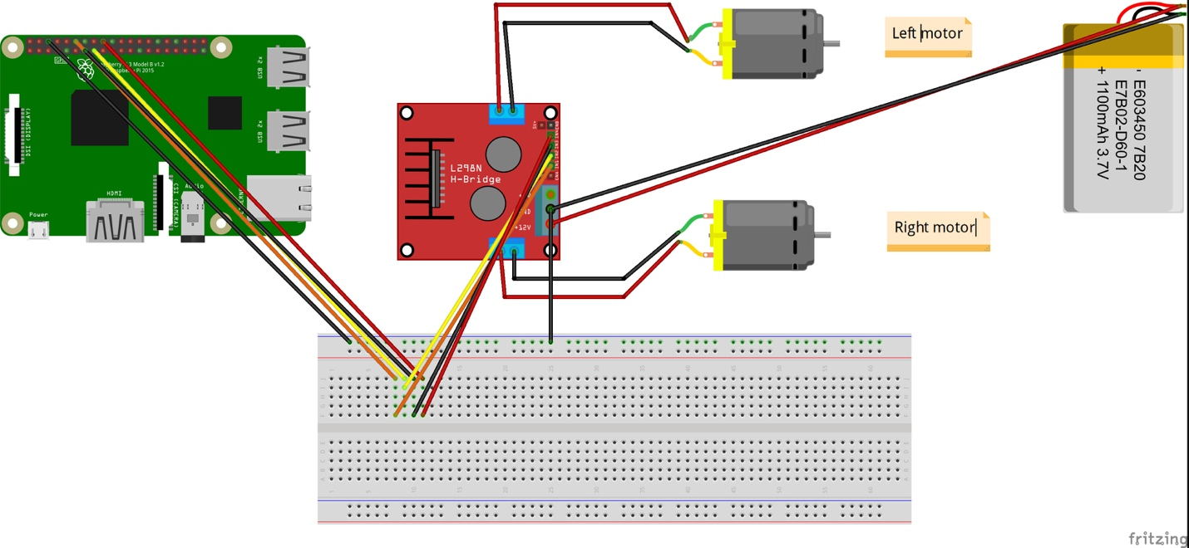

## Figure 3.2 – Wiring Diagram – Swivel Camera

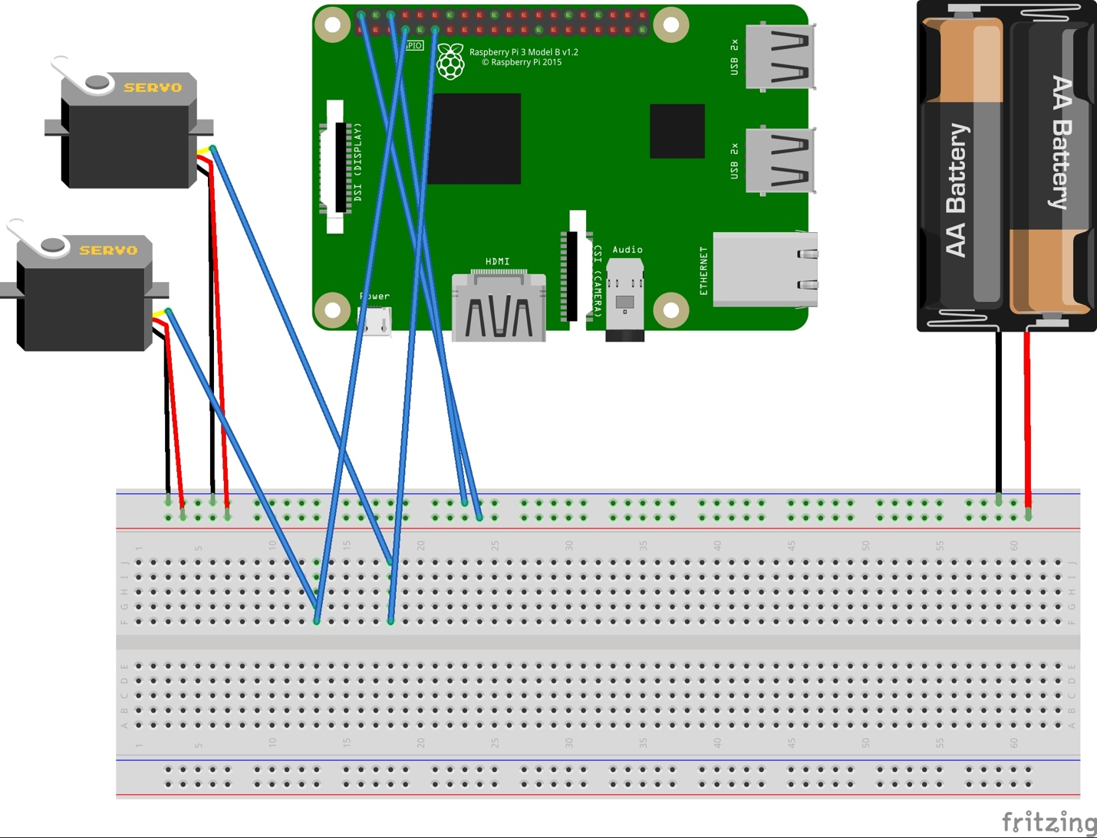

# 4.0 Process

# 5.0 Conclusions

# 6.0 Recommendations

# 7.0 Bibliography

“Remote Control Robots.” *Robot College*, [www.robots-and-androids.com/remote-control-robots.html](http://www.robots-and-androids.com/remote-control-robots.html).

Donkey™ Car. Donkey™ Car. http://www.donkeycar.com/. Accessed March 8, 2019.

# 8.0 Appendices